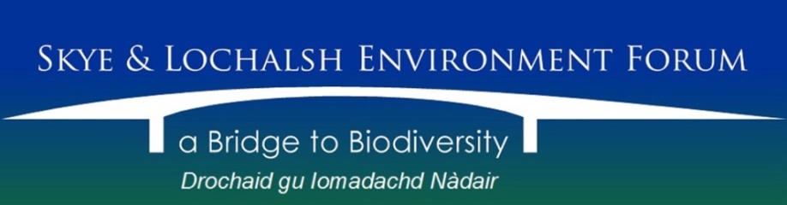

Trustees’ Annual Report
for the period 1st April 2015 to 31st March 2016

The Trustees have pleasure in presenting their report together with the financial statements and the Independent Examiner’s report for the above mentioned period.

Reference & Administrative Information
Charity Name:
Skye and Lochalsh Environment Form

Charity No:
SC040820

Address of Principal Office:
The Old Police Station, Isleornsay, Isle of Skye IV43 8QR

Current Trustees (elected on 31st March 2016):
Eileen Armstrong
David Ashford
Roger Cottis
Louise Love
Ellie MacLennan
James Merryweather
John Phillips
Mike Taylor

Trustees who served during the period:
Eileen Armstrong
David Ashford
Judith Bullivant
Roger Cottis
Louise Love
James Merryweather
John Phillips
Mike Taylor

Structure Governance & Management
Constitution:
The Charity became a Scottish Charitable Incorporated Organisation on 4th September 2013. It is governed by its constitution which was adopted on 18th November 2013.

Appointment of Trustees:
The Board of Trustees, which normally meets on a bi-monthly basis, consists of the charity’s Trustees and membership of the Board is open to all Members of the charity.
Trustees are elected at the Annual Members’ Meeting. Under the constitution, there must be a minimum of three and not more than nine elected Trustees. The Trustees may co-opt a further three Trustees if they consider it would be in the interests of the charity to do so.

Management:
The Trustees are responsible for the strategic direction and governance of the charity, whilst day-to-day running is delegated to the Secretary.

Objectives & Activities
Charitable purposes:
To be a forum for members of the public and organisations in or associated with Skye and Lochalsh in order to promote and care for the landscape and biological diversity of natural and cultural habitats throughout for the benefit of present and future generations and to promote awareness, enjoyment, research, understanding and sustainable use of the Area’s natural and cultural environment and biodiversity.

Activities:
Survey work
A team of volunteers, coordinated by Roger Cottis and assisted with boat transport by Judith Bullivant, undertook a major survey of wood ant nests in the Mudalach area of the Kinloch Hills Forestry Commission Scotland site. This worthwhile piece of citizen science brought in the very useful sum of £800 from Forestry Commission Scotland’s Inverness, Ross & Skye Forest District Environment team to the SLEF account. Some additional work was done to extend the previous year’s adder survey, also at Kinloch Hills, however the initiative was poorly supported and little further data was generated.

Local Biodiversity Action Plan
A sub-group of SLEF (Roger Cottis, Louise Love, James Merryweather and John Phillips) met with Ro Scott, who was contracted to review the Local Biodiversity Action Plan for Skye and Lochalsh. After a good amount of input from the above board members and others, the review was published in May 2015. The review of the plan can be viewed in full here. The original Local Biodiversity Plan can be viewed here. The review reported a significant input from SLEF in delivery of LBAP objectives through the years reviewed (2003-14).

Scottish Salmon Think-Tank
Towards the end of the period here reported on, a decision was made to incorporate the group Scottish Salmon Think-Tank (SST-T) as a working group within SLEF. Furthermore it was decided that SST-T would be able to use SLEF’s banking facilities on the basis that monies received from them will be held as restricted funds. This enables this worthwhile initiative, headed up by board member Dr. James Merryweather, to operate on a sound financial footing, with the added benefits conferred to SST-T by incorporation within the structure of the SLEF SCIO.

Marine biodiversity
A number of objections to fish farm developments were lodged by SLEF in the period. The year 2015-16 ended with our Annual Members’ Meeting which featured presentations from Conor Ryan, then Science and Policy officer for the Hebridean Whale and Dolphin Trust on the problems faced by Cetaceans (Whales and Dolphins) in Hebridean waters and our own Dr James Merryweather on the work of the small, but active group, Scottish Salmon Think-Tank. The topics chosen signal a dedication by SLEF to address the issue of marine environmental health robustly, ever mindful of the need to champion the interests of local sustainable marine practitioners in the tourism, aquaculture and fisheries sectors.

_______________________________________

Approved by the Trustees on 21st December 2016 and signed on their behalf by:

John Phillips
Chair

