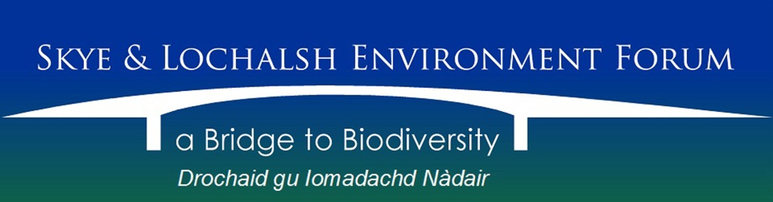

APPLICATION FOR ORDINARY MEMBERSHIP

Skye and Lochalsh Environment Forum (SLEF) is a Scottish Charitable Incorporated Organisation (SCIO). Its Articles of Association include the following provisions:

Charitable Purposes:
To be a forum for members of the public and organisations in or associated with Skye and Lochalsh in order to promote and care for the landscape and biological diversity of natural and cultural habitats throughout for the benefit of present and future generations.
To promote awareness, enjoyment, research, understanding and sustainable use of the natural and cultural environment and biodiversity.

Liability of Members
Members are not liable to contribute to the assets of the SCIO upon its winding up.

Current membership is free and open to everyone aged 16 and above. Membership gives you the right to:
- nominate and be nominated as a Trustee;
- vote during elections of Trustees and at all Members Meetings;
- have your say on policy and direction.

-------------------------------------------------------------------------------------------------------------------------

Skye and Lochalsh Environment Forum - MEMBERSHIP APPLICATION FORM
Name: ….………………………………………………………………………………………………………….

Address: ………………………………………………………………………………………………………………………………………………….

Postcode: …………………………………… Tel: ………………………………………………

Email: ………………………………………………………………………………….

I hereby apply to be an Ordinary Member of SLEF and confirm that I am agreeable to being sent information by email provided that my email address will not be provided to third parties.

Please state what particular interest you have in furthering the Purposes of SLEF.

… ………………………………………………………………………………………………………………………………………………………………………

…………………………………………………………………………………………………………………………………………………………………………

Signed: … ……………………………………………………… Date: ........................................

Please return to: Rob Ware, Secretary at info@slef.org.uk

