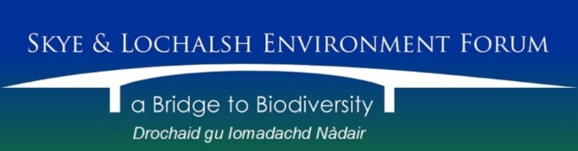

Trustees’ Annual Report
for the period 1st April 2024 to 31st March 2025

The Trustees have pleasure in presenting their report together with the financial statements and the Independent Financial Examiner’s report for the above-mentioned period.

Reference & Administrative Information
Charity Name: Skye and Lochalsh Environment Forum

Charity No: SCO40820

Address of Principal Office: 1, Old Bar View, Lochloy, Nairn, Scotland IV12 5BY.

The Trustees:
Roger Cottis
Lindsay Thatcher
Robert David Ware
Melanie Watt

All served as Trustees throughout the period.

Structure Governance & Management
Constitution:
The Charity became a Scottish Charitable Incorporated Organisation on 4th September 2013. It is governed by its SCIO Constitution which was adopted on 18th November 2013.

Appointment of Trustees
The Board of Trustees, which normally meets at least thrice annually, consists of the charity’s Trustees. Trustees are elected at the Annual Members’ Meeting. Under the constitution, there must be a minimum of three and not more than nine elected Trustees. The Trustees may co-opt a further three Trustees if they consider it would be in the interests of the charity to do so. Membership of the Board is open to all Members of the charity.

Management:
The Trustees are responsible for the strategic direction and governance of the charity, whilst day-to-day running is delegated to the Secretary.

Objectives & Activities
Charitable purposes:
To be a forum for members of the public and organisations in or associated with Skye and Lochalsh in order to promote and care for the landscape and biological diversity of natural and cultural habitats throughout for the benefit of present and future generations and to promote awareness, enjoyment, research, understanding and sustainable use of the Area’s natural and cultural environment and biodiversity.

Activities in the year 2024-2025

SLEF.

The 50 Years of Litter on Skye project continued through Loughborough and Keele Universities. SLEF hosted online meetings to discuss future administrative funding. Once agreed, SLEF continued to oversee a financial package for the coming year, which entailed paying funds as required and advertising events through the SLEF website and Facebook page.

Following the Pine Marten mammal instruction courses a den box is due to be installed at a quiet location in south Skye, which will be monitored. Advice was given about how to deal with martens invading hen coupes and dwellings, whilst allowing the martens inside the property, but confining their movements. The female pine marten with injuries following a suspected cat attack was observed using trail cameras. It transpired that she had recovered well and produced two kits.

An otter talk to the Friends of Loch Duich was well received by 40 enthusiastic members on 5th January 2025. During March, two otter instruction walks were undertaken to inform Skye and Lochalsh people who signed up through Sleat Nature Group. 19 people attended over the two days. Otter paths, freshwater pools used for drinking and coat washing together with distant views of minor holts (rest sites) were visited. Other signs were shown, including regularly used spraint (faecal) sites, which enriched the grass turning it a brighter green from the surrounding vegetation.

The badger site in Lochalsh continued to be monitored and one cub was successfully reared.

During the year, SLEF’s Secretary continued to publish regular newsletters with articles relating to environmental issues across the area. SLEF members, Trustees and other environmental groups and interested individuals contributed articles and photos on a very wide-ranging selection of environmental topics across the region.

SLEF also continued to publicise environmental events and issues of interest both locally and more widespread through social media. A number of films produced by one of our members were added to the SLEF YouTube channel, these are for educational purposes.

SLEF has continued providing support for 3 other environmental organisations during the year. These groups do not have their own bank accounts, so have benefited from SLEF holding and administering their funds.

The future role of SLEF has been under review by the Trustees this year. We were fortunate to have the Community Support Specialist from Fauna and Flora host a workshop for us in April 2024, which discussed various options. These are still being considered.

Approved by the Trustees on 13th December 2025 and signed on their behalf by:

Roger Cottis
Chairman.

