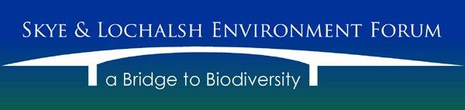

Activities:
There was one Trustee resignation and the election of one new Trustee to the Board who became the Secretary.
Inviting Members to attend Board meetings was abandoned in the light of the national Covid outbreak. This prolonged outbreak rendered most activity to online meetings by way of Zoom.
During this time the new Secretary devised a Members Newsletter to keep Members informed. The publication was well received and continued the information stream of SLEF, South Skye Seas Initiative (SSSi) and to a lesser extent Scottish Salmon Think-Tank (SST-T).
SST-T remained active, but with a new remit, that of advice regarding how communities could react to open net fish farm applications, where biodiversity would be adversely impacted. The advice was comprehensive, with publications and videos being made available.
SSSi continued where possible, given Covid restrictions, to undertake surveys of Skye’s sea lochs where new seagrass (Zostera marina) beds were detected. Some were from boat surveys with a remotely operated vehicle (ROV) and others from kayaks and paddleboards using GoPro cameras. The results were collated and disseminated to NatureScot. The ROV experienced problems and with some of the remaining project funds from William Grant Foundation, solutions were found and implemented, however, testing was compromised with the survey boat needing to be moved to a remote overwinter mooring.
Struan Primary School was supported in their Ocean School project with two Trustees visiting when appropriate and advising about Priority Marine Features as part of their project. A joint survey was carried out.
An intertidal sea and mollusc core temperature project was initiated using Robo-limpets with funding from the Flora and Fauna Community Support Fund and will be operational in 2023. The battery life of the units is around seven years and will contribute data to a national survey, which is considered important with climate change issues needing accurate data. Here SLEF was able to support two other adjacent mainland communities with their Robo-limpet projects.
SLEF undertook badger and otter instruction courses. These involved providing papers on each species followed by a PowerPoint presentation and when possible, fields trips to sites for observing and identifying features to determine each species.
SLEF provided a speaker for the development of Scottish Badgers formation of a Skye & Lochalsh Branch. An online presentation gave an insight in to Highland badgers and was well received by around 65 people.
Engagement with likeminded organisations remains a priority and membership recruitment will continue.
Approved by the Trustees on 16th December 2022 and signed on their behalf by:
Rob Ware: Secretary Skye and Lochalsh Environment Forum

