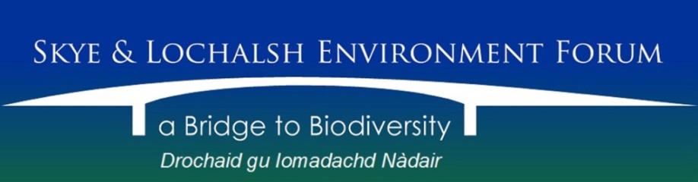

Trustees’ Annual Report
for the period 1st April 2014 to 31st March 2015

The Trustees have pleasure in presenting their report together with the financial statements and the Independent Examiner’s report for the above mentioned period.

Reference & Administrative Information
Charity Name:
Skye and Lochalsh Environment Form

Charity No:
SC040820

Address of Principal Office:
The Old Police Station, Isleornsay, Isle of Skye IV43 8QR

Current Trustees (elected on 18th November 2013):
Eileen Armstrong
David Ashford
Judith Bullivant
Roger Cottis
Louise Love
James Merryweather
John Phillips
Mike Taylor

Trustees who served during the period:
Eileen Armstrong
David Ashford
Judith Bullivant
Roger Cottis
Louise Love
James Merryweather
John Phillips
Mike Taylor

Structure Governance & Management
Constitution:
The Charity became a Scottish Charitable Incorporated Organisation on 4th September 2013. It is governed by its constitution which was adopted on 18th November 2013.

Appointment of Trustees:
The Board of Trustees, which normally meets on a bi-monthly basis, consists of the charity’s Trustees and membership of the Board is open to all Members of in the charity.
Trustees are elected at the Annual Members’ Meeting. Under the constitution, there must be a minimum of three and not more than nine elected Trustees. The Trustees may co-opt a further three Trustees if they consider it would be in the interests of the charity to do so.

Management:
The Trustees are responsible for the strategic direction and governance of the charity, whilst day-to-day running is delegated to the Secretary.

Objectives & Activities
Charitable purposes:
To be a forum for members of the public and organisations in or associated with Skye and Lochalsh in order to promote and care for the landscape and biological diversity of natural and cultural habitats throughout for the benefit of present and future generations and to promote awareness, enjoyment, research, understanding and sustainable use of the Area’s natural and cultural environment and biodiversity.

Activities:
Throughout the period 1st April 2014 to 31st March 2015 a wide range of activities were undertaken by Skye and Lochalsh Environment Forum including the following:
The private collection of Andrew Currie, botanist and one-time Area Officer for the Nature Conservancy Council, who died in March 2012 (see here for details of Andrew’s life), was moved by SLEF Board Members Roger Cottis and John Phillips to a temporary location at Balmacara courtesy of National Trust for Scotland. A start has been made in dealing with this collection, comprising an extensive range of periodicals and herbarium sheets of local and wider interest plus various other printed materials. The herbarium material has been catalogued and transferred to the collection at the Royal Botanic Garden in Edinburgh, under the supervision of Stephen Bungard, BSBI botanical recorder for the area. Board Member Louise Love has made good progress in cataloguing the periodicals. The major task for the future is to find a long-term home for the remaining material which, along with the equipment purchased as part of the SLEF Outreach Project, is taking up space in the NTS base at Balmacara.
The initial phase of the Kinloch Reptile Survey undertaken by SLEF under contract to Forestry Commission Scotland was completed during this period and the data submitted to FCS. This work was considered worth continuing and a further project was proposed to carry on into the 2015-16 period.
A decision was made to mark the untimely death of SLEF Member Annabel Pendlebury in April 2014 by setting up an annual award for environmental work at Sleat Primary School, with which Annabel had been closely involved in her later years.
Local environmental concerns taken on by SLEF were wide-ranging in this period and included:
- Impact of Distillery development at Knock on bats;
- Proposed new bothy at Dalavil;
- Impact of Plock development on otters (the well-publicised otter mitigation measures at this location were compromised without reaction from Highland Council planners or Transport Scotland, both of which should have been well aware of these measures);
- Cutting of roadside Japanese Knotweed by BEAR contractors with the likely resultant spread of this problem species;
- Proposed new fish farm developments at Loch Eishort and Loch Slapin.
Two meetings took place during the period of this Report between a subgroup of the SLEF Board and contractor Ro Scott, to progress the long-awaited review of the Local Biodiversity Action Plan.
On Friday, 6th February 2015, SLEF hosted a public event exploring the question: Do children and young people connect to nature enough? As well as leading a wide-ranging discussion, Terri Harrison, founder of Nature Nurture, gave a presentation about the transformative effect that connecting with nature has on children and young people, including how to encourage ‘screenagers’ out-of-doors.
Thereafter followed a discussion about ‘Nature Deficit Disorder’ with inspirational and informative video extracts, including one from the internationally acclaimed film ‘Project Wild Thing’ and from Richard Louv (author of 'The Nature Principle' & 'Last Child in the Woods').
Membership stood at 70 by the end of the period with Members from throughout the Skye & Lochalsh area.

Plans for Future Periods

Continue with Kinloch Reptile Survey.
Complete review of Local Biodiversity Action Plan.
Continue to respond to Fish Farm applications locally.
Undertake Wood Ant survey at Mudalach section of FCS holding at Kinloch-Kylerhea under contract to FCS.
Progress finding an appropriate home for the Andrew Currie collection.

_______________________________________

Approved by the Trustees on 10th December 2015 and signed on their behalf by:

John Phillips
Chair

